**Sprint 2 UI Prototypes**

**Table of Content**

**User Story 1 2**

- US-1.1 2

**User Story 2 3**

- US-2.1 3

- US-2.2 3

- US-2.3 3

**User Story 3 5**

- US-3.1 5

- US-3.2 5

- US-3.3 5

**User Story 4 7**

- US-4.1 7

- US-4.2 7

# User Story 1

## - **US-1.1**

As a public user, I want to insert the registration key to access the application content.

## 

**Claiming Condo page**

Steps:

1- After signing up or logging in (without having entered the key before), the user is automatically taken to this page.

2- The user enters the registration key they received from their condo management company, and presses on “claim condo”.

3- The user is taken to the condo’s dashboard if the registration key is correct. Otherwise, they will have to enter the key again, until it is the correct one.

# User Story 2

## - **US-2.1**

As a condo owner, I want to check my finances: the required monthly payments, download the past invoices and check any additional fees

## - **US-2.2**

As a condo owner, I want to see the updates concerning my submitted requests

## - **US-2.3**

As a condo owner, I want to see the available amenities and their opening hours

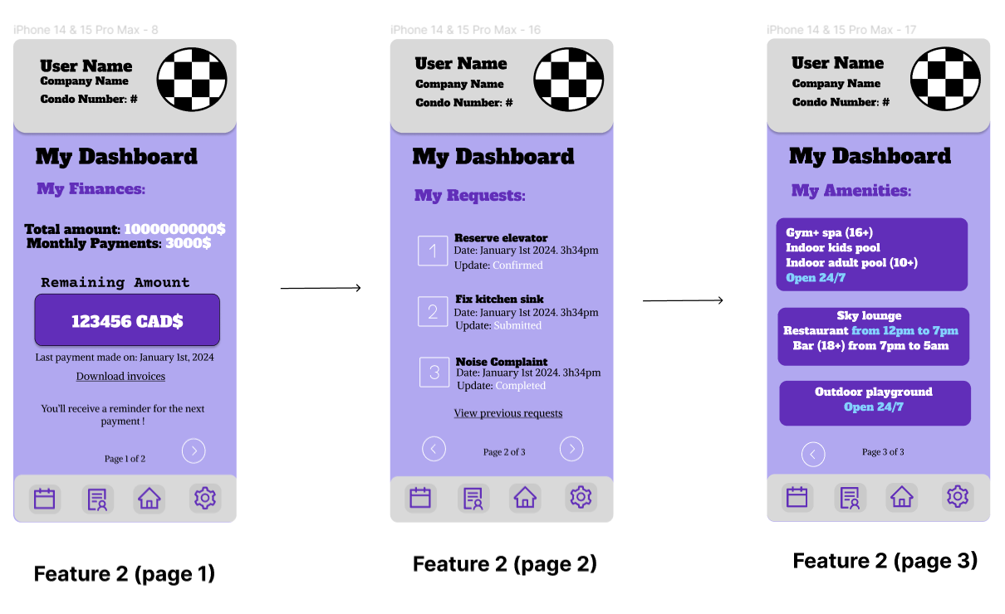

**Condo dashboard combining user stories 2.1, 2.2, 2.3**

Steps:

1- To land on the first page, the user is either new to the app and has just inputted the registration key, or the user is not new to the app and has clicked on the home button on the footer.

2- On the first page, the user can see the total price of the condo, the monthly payments due, and the remaining amount from the total price of the house. The user can also download invoices from past payments by clicking on the “download invoices” link, and they can see when the date of the last payment was made. Finally, the user will receive a reminder of the next due payment. To navigate to the next page, the user clicks on the white arrow on the bottom right of the page.

3- On the second page, the user can see all the submitted requests, the updates concerning each one, as well as the date each one was submitted. If the user has made more than 3 requests, they can click on “view previous requests” to see the rest of the requests.

4- The user can go back to the previous page using the left white arrow at the bottom of the page, or they can go to the next page by using the right white arrow at the bottom of the page.

5- On the third page, the user can see the amenities that are accessible to them, as well as the opening hours and age restrictions. The user can go back to the previous page by clicking the white arrow on the bottom left of the page.

# 

# User Story 3

## - **US-3.1**

As a rental user, I want to check my finances: the rent, past payments, and the date of the next expected payment (which is on the first of the month).

## - **US-3.2**

As a rental user, I want to see the updates concerning my submitted requests

## - **US-3.3**

As a rental user, I want to see the available amenities and their opening hours

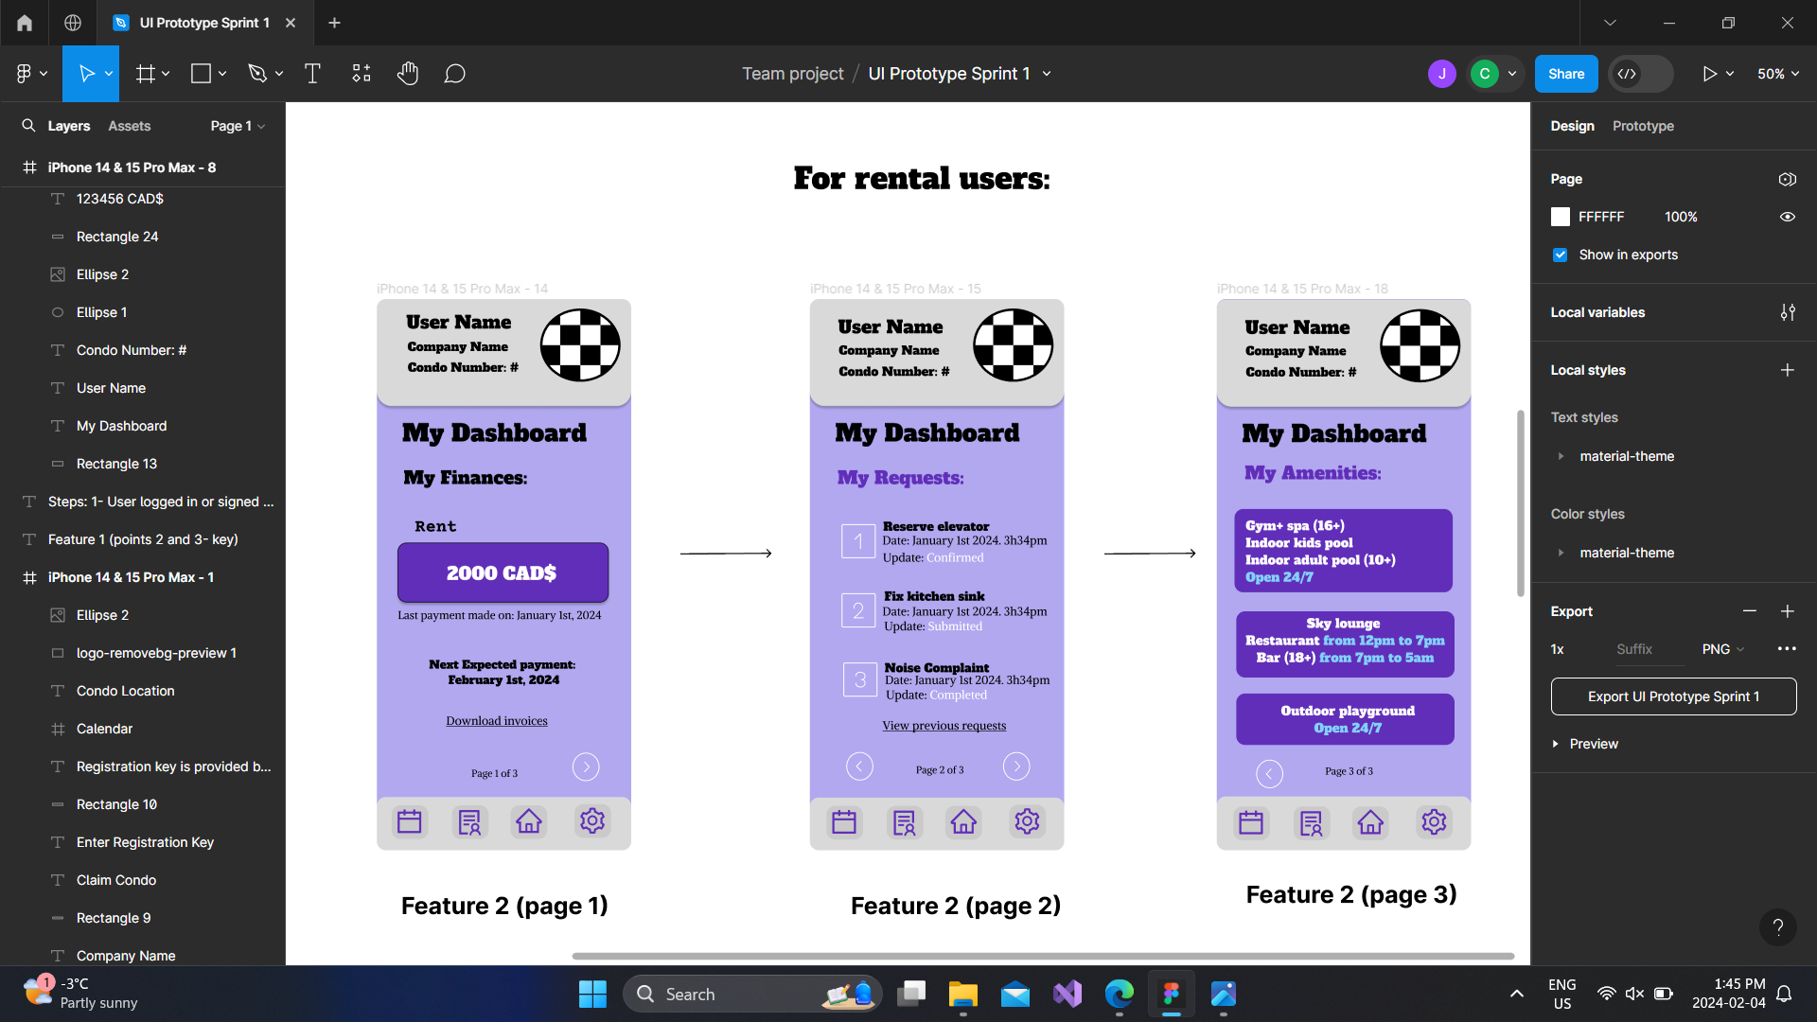

**Condo dashboard combining user stories 3.1, 3.2, 3.3**

**(pages 2 and 3 are identical for condo owners and rental users)**

Steps:

1- To land on the first page, the user is either new to the app and has just input the registration key, or the user is not new to the app and has clicked on the home button on the footer.

2- On the first page, the user can find the rent, the date of the last payment made, and the date of the next expected payment, which is on the first day of the month. The user can also download invoices for past payments by clicking on “download invoices." To navigate to the next page, the user clicks on the white arrow on the bottom right of the page.

3- On the second page, the user can see all the submitted requests, the updates concerning each one, as well as the date each one was submitted. If the user has made more than 3 requests, they can click on “view previous requests” to see the rest of the requests.

4-The user can go back to the previous page using the left white arrow at the bottom of the page, or they can go to the next page by using the right white arrow at the bottom of the page.

5- On the third page, the user can see the amenities that are accessible to them, as well as the opening hours and age restrictions. The user can go back to the previous page by clicking the white arrow on the bottom left of the page.

# 

# User Story 4

## - **US-4.1**

As a condo management company, I want to be able to register a condo with all its information, from the unit size to the dedicated parking spot.

## - **US-4.2**

As a condo management company, I want to be able to send a registration key to the occupant of the corresponding condo.

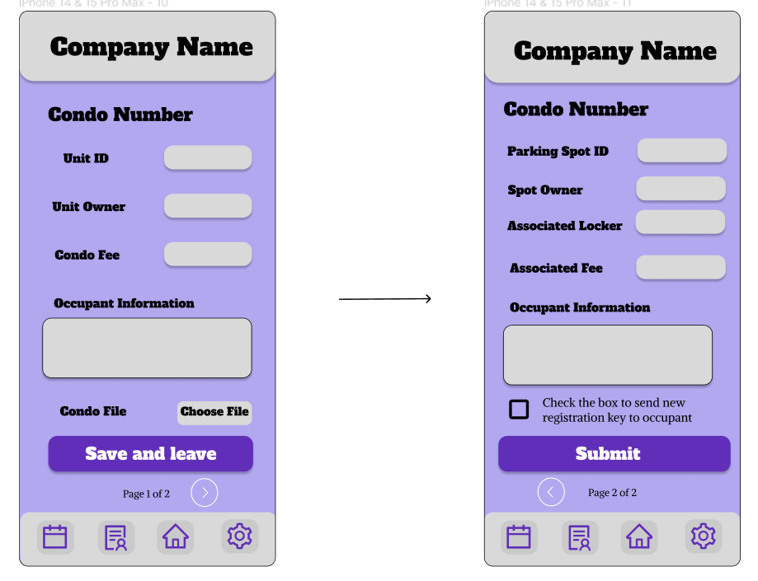

**Condo, parking, and locker info combining user stories 4.1, 4.2**

Steps:

1- The user searches for a specific property, if available, or creates a new one.

2- The user adds a file containing information about the condo and fills in the required fields (add or edit).

3- The user clicks on “save and leave” and goes back to the properties page automatically, or the user clicks on the arrow button to go to the next page.

4- Once on the next page, the user has the option to go back to the previous page or press “submit” to save all changes and go back to the properties page.

5- if the user checks the box, the occupant of the corresponding condo will receive a new registration key.